**S S Sai Gopala Pavan Rutwik Manapragada**

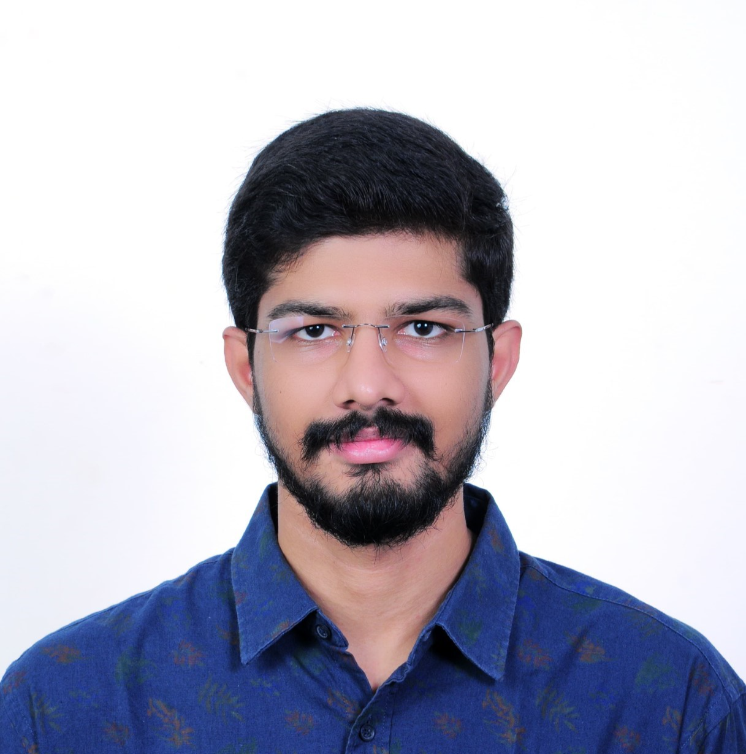

|  |  |
| --- | --- |
| **Title:** | Consultant |
| **Location:** | Hyderabad, India |
| **Languages:**  **Email-id:**  **Mobile number:** | Telugu (Native),English (Fluent), Hindi (Fluent)  RUTWIK.MANAPRAGADA@CAPGEMINI.COM  +91 8790175295 |

# Experience Summary

* 4.3 years of experience in designing, developing, and optimizing scalable software solutions.
* 4+ years of experience in backend development using Java, Spring Boot for building robust and scalable applications.
* 2 years of experience in developing RESTAPIs using Java and Spring boot.
* Hands on experience to write code using Java.
* Hands on experience in J2EE frameworks like Spring Boot.
* Proficient in writing Unit Test cases by using testing tools Junit, Mockito and Rest Assured.
* Hands on experience in Source repository tools GIT.
* Good experience in application build tools Maven/Gradle.
* Involved in client calls at various levels to getting keen understanding of the Requirements.

**KEY SKILLS:**

* Programming Languages: Java, J2EE
* Frontend Development: HTML5, CSS3, Adobe XD, Figma
* Backend Development: Spring Boot, Microservices, RESTful APIs, Swagger, Rest Assured, Postman, Concourse, ArgoCD, Jenkins
* Database Management: SQL, Data Analysis & Visualization, New Relic, Splunk
* Software Development: Java 1.7 to Java 11 migration
* System Integration & Scalability: RESTful API Development
* Collaboration & Problem-Solving: Cross-functional Teamwork, Agile Development, Requirement Analysis

# Experience

### **Project 1: Outcomes**

**Industry:** Healthcare

#### Description:

* Worked on a healthcare product that managed patient prescriptions and pharmacy services. The project involved integrating multiple external systems, ensuring secure authentication, and optimizing API performance for high availability. Developed RESTful APIs using Java and Spring Boot while implementing best practices for scalability, security, and maintainability.

#### Role: Software Engineer-2

**Duration:** May 2024 – Feb 2025

### **Responsibilities:**

* Designed and developed RESTful APIs from scratch, ensuring adherence to best practices and proper documentation using Swagger.
* Implemented JWT-based authentication and security.
* Built, tested, and deployed APIs across fluffle, non-prod, and prod environments, ensuring seamless integration with external clients.
* Conducted rigorous API testing using Rest Assured, JUnit, and Mockito, ensuring accurate data retrieval, proper exception handling, and adherence to HTTP status codes.
* Wrote Terraform scripts to automate API deployments and managed configurations in AWS API Gateway.
* Integrated APIs with Concourse CI/CD pipeline and deployed services using ArgoCD to maintain a streamlined DevOps workflow.
* Collaborated with cross-functional teams to troubleshoot production issues, ensuring minimal downtime and high availability of services.
* Maintained comprehensive technical documentation to facilitate onboarding and troubleshooting for future developers.

### **Technologies Used:**

* Backend: Java, Spring Boot, Spring REST, Spring Security
* Build Tools: Gradle
* Testing: Mockito, JUnit, Rest Assured
* Authentication: JWT
* CI/CD & Deployment: AWS API Gateway, Terraform, Concourse, ArgoCD, Postman

### **Project 2: Oracle Cerner**

**Industry:** Healthcare

#### Description:

* Worked on Capman and CareView, two critical healthcare products designed to streamline patient management within hospitals. Capman handled patient transfers, transport, and discharge processes, while CareView provided a real-time dashboard displaying patient details, including room assignments. The projects involved resolving client-reported defects, modernizing legacy applications, and enhancing system reliability.

#### Role: Software Engineer-1

**Duration:** May 2024 – Feb 2025

### **Responsibilities:**

* Analyzed and fixed client-reported defects, improving the stability and reliability of both Capman and CareView applications.
* Led the Java 8 to Java 11 migration for Capman application.
* Refactored code to replace deprecated javax annotations with Jakarta annotations, ensuring seamless compilation and runtime stability in Java 11.
* Developed and tested new features as per the requirements.
* Collaborated with cross-functional teams, including QA, DevOps, and Product Management, to ensure timely releases with minimal regression.
* Enhanced deployment pipelines, ensuring smooth CI/CD integration with Jenkins and reducing build failures.
* Maintained detailed technical documentation, aiding in troubleshooting and onboarding new developers.

**Technologies Used:**

* Backend: Java 8 → Java 11
* Build & CI/CD: Maven, Jenkins
* Migration & Modernization: Java 11 compatibility fixes

### **Project 3: Cognizant**

**Industry:** Banking

#### Description:

* Worked as a Frontend Developer in the banking domain, focusing on designing and developing user-friendly web interfaces. Created interactive prototypes using Adobe XD and Figma, ensuring seamless alignment between design and development. Collaborated closely with the team to enhance UI/UX and optimize the overall user experience for banking application.

#### Role: Programmer Analyst Trainee

**Duration:** Aug 2020 – July 2021

### **Responsibilities:**

* Designed and developed responsive web pages using HTML, CSS, and React JS, ensuring cross-browser compatibility and mobile responsiveness.
* Created high-fidelity UI/UX prototypes using Adobe XD and Figma, providing visual representations of web pages before development.
* Ensured adherence to UI/UX guidelines for accessibility and usability.
* Collaborated with the team to document and share best practices for frontend development and workflow improvements.
* Explored and gained hands-on experience with MongoDB, learning fundamental concepts of NoSQL databases.

**Technologies Used:**

* Frontend: HTML, CSS, React JS
* Design & Prototyping: Adobe XD, Figma
* Database: Introduction to MongoDB
* Collaboration: Agile, Team documentation & knowledge sharing

##### Higher Education

* **SASTRA UNIVERSITY, Thanjavur - Bachelor of Engineering**
* Electrical and Electronics engineering , 07/2020.